This confirms that

Click or tap here to enter text.

Joined with over 100 other Beavers, Cubs, Scouts and Leaders from 1st Harpenden to participate in CampAtHome 2020

CONGRATULATIONS !

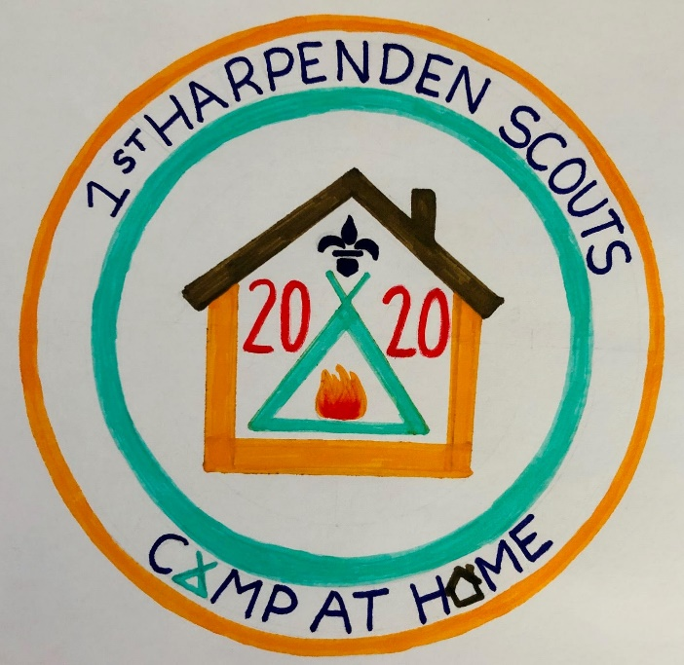

Signed: Andy Wrentmore
Group Scout Leader
Date: 1 June 2020

